

TECHNICAL PROPOSAL

NEPA WEB PORTAL
Attention: Mr.Tahsinullah Submitted By: Mujtaba Akhlaqi

INOVORA Aug-2018

Table of Contents

1. SUMMARY 3

1.1. | GOAL | 3
1.2. | OBJECTIVES | 3

2. PROPOSED SOLUTION 3

2.1. | FUNCTIONAL SPECIFICATIONS | 5
2.2. | TECHNICAL APPROACH | 7
2.3. | DEVELOPMENT METHODOLOGY | 9
2.4. | PROJECT TIMELINE | 9
2.5. | PROJECT STAFF | 10

3. ORGANIZATION BACKGROUND 11

3.1. ABOUT INOVORA 11

4. ANNEX I: PROJECT TIMELINE 11

1. Summary
National Environmental Protection Agency (NEPA), intends to create a project under the name of the creation of the National Information System or environmental Web Portal, which is needed to create a comprehensive and systematic database at the backend in order to provide all environmental information in its various generic sections displayed in charts.
1.1. Goal

Development of an integral web portal for national environmental protection agency (NEPA) equipped with a comprehensive database at the backend.

1.2. Objectives

NEPA web portal system will have the functionality of covering all aspects and subjects of natural environment including pictures, videos, texts, maps, rules and regulation, reports and etc. The proposed system will be able to generate dynamic forms suitable and appropriate for specific environment characteristics. The system will also have the ability to generate comprehensive and reliable reports with elegant designs. The system will also be equipped with GIS mapping to make the process of inserting and reading data more easily. In order for the above mentioned objectives to come true, we will build the following modules during the development of the system:

- Environmental supervision and assessment
- Rules and Policy
- International relationships
- Preserve of the natural environment
- Assessment and sustainable development
- Climate change module
- Contacts module
- GIS mapping module
- Advance search/Reporting module
- Android and iOS mobile app

2. Proposed Solution

Based on our years of experience in IT sector and specifically in development of different web-based portals, INOVORA will assure the development of a secure, available and reliable web portal to ensure an effective and efficient process for the day-to-day operations of surveying areas, assigning arbitral forms to surveyors, publishing contents on the web and extracting comprehensive reports for the office.
As security is a big concern in today’s world of information and technology, and specifically in web-based/online portals as they are accessible and a wide range of users all over the world, considering all the security concerns mentioned in the announced RFP, we will apply different security measures during the development phase of the NEPA Web Portal to protect data from unauthorized access, use, disclosure, disruption, modification or destruction. Role based access control module will be developed to restrict system access to unauthorized users. Different user access roles will be created and the permissions to perform certain operations in the system will be

assigned to specific roles. All user login credentials will be entirely encrypted in the same database of the NEPA Web Portal.

The major need in today’s information systems in general is for improving the logic of data entry and creating comprehensive and advanced reports of those entered data. Our team will design a user friendly and easy-to-use interface for the data entry compartments of the NEPA Web Portal and will also apply comprehensive and three layered data validation and correction process before storing data to the NEPA Web Portal database. Applying data validation and correction process will result in storing clean, correct and useful data to the NEPA Web Portal system. Reports are generated based on the available data in a NEPA Web Portal database; the cleaner and complete the data is stored in the database, the more reliable and accurate the reports will be. The authority to validate and correct the data will the given to the data approvers which are a group high level users in the system.
A report generator module will be developed for the NEPA Web Portal, in which the users will be able to generate different types of accurate custom reports quickly. we will make sure that the reports generated by the system are presented in a way that is most readily understood by the targeted reader/user. With the report generator module; users will be able to generate analytical data charts and graphs from the available data in the NEPA Web Portal Database.

2.1. Functional Specifications

We will make sure all of the below listed functionalities and the features mentioned in the ToR documents submitted by NEPA for the development of NEPA Web Portal system are fully designed and developed.

• User Interface: Interactive, user-friendly and responsive user interface will be designed for the NEPA system, users/viewers will be able to access the NEPA system in different types of devices i.e. smartphones, tablets and PCs. NEPA Web Portal user interface will have compatibility with different types of web browsers. Additionally, we will build two Applications for the system for android and iPhone users that will have access to the same functionalities that the system acquires in general.
• User Access Roles: NEPA Web Portal users will be provided with different access levels/roles; user access roles will be created based on the NEPA Web Portal requirements. We will create four categories of roles in general, where three of them are assigned directly to their associated users, but one of the roles which is going to for admins, will have more subdivisions, each one with slightly differences authorities from another.
• Search: An internal search function will be developed to extensively search any type of data available in the NEPA Web Portal database, with highly consistent results. Users will have the option to filter search results based on different criteria coming from client side.
• Reports: NEPA users will be able to generate accurate and consistent reports based on requirements coming from NEPA side, Reports function will support the generation of dynamic/user-customized reports, it will also store reports in many file formats such as CSV, excel and PDF and are able to be copied and printed. Users will have the option to categorize reports on a daily, weekly, monthly and yearly basis and also according to province, district, village factors and more.

• Data-Backup: Our team will develop a data-backup function to enable NEPA Web Portal system administrator to manually backup system data, we will also add the functionality of automatic backup process on a daily, weekly, monthly and yearly basis. In case of a sudden data loss the backup function will also have the functionality to restore a previously backup archived file.

2.2. Technical Approach

Understanding of the modules involved in the NEPA Web Portal and their relationships and interdependencies with each other in the organizational-processes set for daily operations within organization is one the most important aspects of developing the NEPA Web Portal’s system architecture. We will work closely with our system engineers; who are professional and experienced in designing system architecture for different web portals and other information systems. Our system engineers will play an important role in designing system architecture for the NEPA Web Portal, this will help our system engineers with a broader understanding of processes, relationships and challenges between the current working- processes, and that understanding will be very useful in the further development and management of requirements. Every system architecture is different and NEPA Web Portal indeed has its own complexity; our system engineers are able to identify and to bridge the complexity in a way that reduces risk and cost for our client.
Starting development without a proper architectural design perspective, approach, or
Consideration could lead to unneeded redundancy, complexity and purposeless constraints. Considering the time constraint for implementation of the project, our system engineers will apply Model-based Systems Engineering methodology and use a top-down approach to define NEPA Web Portal’s system architecture. By using a top-down approach it is possible to define new system requirements and new system architecture starting from organizational processes analysis.

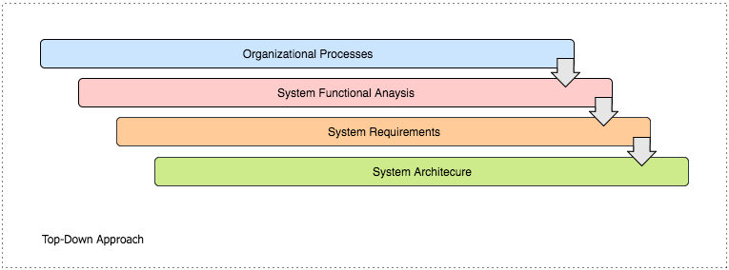

Organizational processes describe interactions between actors in an organization, in order to carry out all the activities in those processes one or many different systems can be used. Organizational processes analysis will lead us to the definition of system context and Use Cases can be directly derived by activities, which are carried out with the system of systems during organizational processes.

During the functional analysis phase, we will define functionalities and system requirements. We will also be able to define Test Cases during this phase, by tracing functional requirements towards Use Cases; verification of requirements has to be systematic and repeatable. Our system engineers will perform traceability between system requirements by using different tools and methods i.e. traceability matrices or requirements diagrams.
During the system’s requirements analysis phase, system requirements can be grouped under the
definition of functional blocks; these functional blocks will be then part of the system functional architecture. Functional blocks can be organized in an architecture that will show system functional elements and interfaces between functional blocks in the architecture.
Last step of the top-down approach will be the definition of a system logical architecture, which
will satisfy system requirements. All functional blocks will be allocated to logical elements. In model-based systems engineering, the model is leading the development of a system during the
whole lifecycle, from the concept phase to the disposal phase.

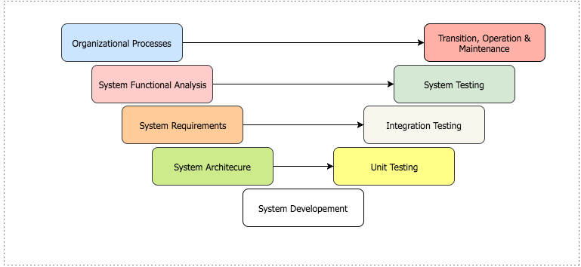

Project will be designed and developed by modern world contemporary technologies and methodologies; our team will use the MVC (Model-View-Controller) architectural pattern for development of the NEPA Web Portal. MVC will divide the system files into 3 interconnected parts to separate internal representation of information from the ways that information is presented to the user.

- Model: Directly will manage the data, logic and rules of the Management Information System.
- View: It is the output representation of information to the user, based on changes in the model
- Controller: Accept inputs and converts it to commands for the model or view.

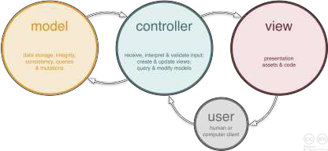

The following technologies will be used to develop the NEPA Web Portal:

• HTML, CSS & Bootstrap for the user interface of the NEPA Web Portal
• JavaScript, jQuery & Ajax for client side data validation and user interactions
• PHP (Laravel framework) for the development of the modules, server side data validation and backend operations
- Plugins: Multiple and up to date plugins for advance search and report generations
• MySQL for the backend database of the NEPA Web Portal
- Android (java) & Swift for the development of the mobile apps for Android and iOS systems

2.3. Development Methodology

Considering time constraints for implementation of the project, our team will use the Agile development methodology to develop the NEPA Web Portal. Agile is an iterative, team-based approach to development. This approach emphasizes the rapid delivery of a NEPA Web Portal module in complete functional components to the client. As the development of a module or a part of the module is completed, it can be reviewed and tested by the project team and the client, this will allow the client to make feedbacks/adjustments if necessary and it gives our team early sight of any quality issues or any errors/bugs detected in a module. Agile approach relies on a very high level of client involvement throughout the project and especially during the reviews of each module.

2.4. Project Timeline

Please check Annex 1.

2.5. Project Staff

The following is a detailed breakdown of the role required to execute the project activities, for each major project activity it includes: the project role, the project responsibility of the role, skills required and the number of staff required to fulfill the role.

Activity | Role | Project Responsibility | Skills Required | No. Staff  Required
Project Coordination | Project Coordinator  – Point of Contact | Run, administer and organize all project activities in cooperation with and under the direction of INOVORA Projects’ Coordination Manager | Excellent written, verbal, client-facing & internal communication skills, | 1
NEPA Web Portal System  Architecture Design | System Engineer | NEPA Web Portal requirements gathering, requirement analysis, work-flow diagram design, data- flow diagram design and overall system architecture design. | Excellent understanding of System Development Life Cycle (SDLC) and various system development methodologies. | 2
NEPA Web Portal Modules Development | PHP and Laravel Developer | NEPA modules and each module’s functionalities development. | Programming, Software Design, PHP, jQuery, Ajax and MySQL | 4
NEPA Web Portal Database Development | MySQL Database  Developer | NEPA Database logical and physical design/development | Database design & development, SQL, MySQL | 1
NEPA Web Portal User  Interface Design | Interface Designer | NEPA Web Portal interface design, client side data validation functionalities design, each modules’ interface design | HTML 5, CSS 3, JavaScript, jQuery, Ajax, PHP and MySQL, JAVA and Swift | 2
System Training and  Testing | Trainer / Tester | NEPA Web Portal functionality testing. Conduct training the users of NEPA Web Portal | Excellent communication skills, problem solving and negotiation skills | 1
Manual Translation  & Technical Documentation Writing | Documentation  Writer | User manual preparation, and technical documentation preparation | Excellent report writing, Excellent English proficiency | 1

3. Organization Background

3.1. About INOVORA

Our unique approach to provide standard solutions and efficient possible quality services to our clients in Government, Corporate entities, small and medium sized organizations as well as individual clients made us to be a preferred IT service provider company by our clients in Afghanistan. Teamwork, putting the client first, going extra miles for our clients along with the world standard product development, quality trainings and standard support services are the key strategies we follow at INOVORA, which made us to lead the market in a very short time in the aforementioned fields.

Mission: With our passion and commitment to our clients, we provide solutions to face real world challenges. We earn and keep our client's trust by delivering standard quality services that exceeds expectations with substantial saving.

Vision: Our vision is to lead ICT Sector in Afghanistan and world by providing the finest solutions, highest quality services and innovation.

At INOVORA we work relentlessly to obtain the best quality results for our clients through our unbroken and consistent operations of services. We are working actively and we strongly believe that our clients’ success is vital to our future business.
We take strategic actions in order to achieve our long-term aims and to secure our interests in the future. We are committed to develop and implement growth opportunities within INOVORA. We seek to develop and create long-term value for INOVORA from our clients and specifically our relationship with clients and the trust we build with our clients.
Our key to success is our team-work and the trust we build and we strongly believe that the strength of a team is each individual member and the strength of each member is the team.

We offer premium services; we develop efficient Information Systems, Web Applications, Desktop Applications, Mobile Application, and quality user-friendly Websites. We provide exceptional quality ICT Trainings, while following world standard methodologies and curriculums to train and build the future’s ICT specialists, developers and experts. We provide ICT Maintenance services to our clients with customer service center that is available 24 hours a day, 7 days a week to complement our clients’ services before, during and after business hours.

4. Annex I: Project Timeline

Project Timeline is attached timeline.pdf

